James Peck

University of Oklahoma

128 West Pulteney Street

Corning, NY 14830 USA

[jamesfpeck@gmail.com](mailto:jamesfpeck@gmail.com)

Kiowa 5 Word Count: 539

The Kiowa 5 was a group of Kiowa artists born in Indian Territory (later Oklahoma) in the first decade of the twentieth century. Stephen Mopope (1898-1974), Jack Hokeah (c. 1900/2-1969), Monroe Tsatoke (1904-1937), James Auchiah (1906-1974), and Spencer Asah (1905/10-1954) were encouraged to paint by relatives, school teachers, and Indian Services personnel. In 1926, Oscar Jacobson, head of the University of Oklahoma art department, created a special program for Kiowa artists at the University. Through Jacobson’s influence, from 1928-1932, the Kiowa 5 exhibited their paintings at the First International Art Exposition in Prague, Czechoslovakia, and at the 1932 Venice Biennale. These exhibitions, along with a portfolio of the artists’ work titled *Kiowa Indian Art*, gained the group critical acclaim in America and Europe. Stylistically, their watercolour paintings featured outlined fields of flat color, with little or no indication of perspective or the third dimension. This flat, linear, decorative style was derived in part from Plains ledger drawings and hide paintings. Their subjects were auto-ethnographic representations of everyday, historically traditional Kiowa life. Their art provided a bridge between Plains ledger art of the late nineteenth century and the flat Studio Style taught to Indian students by Dorothy Dunn in Santa Fe in the 1930s.

The Kiowa 5 gained national and international recognition in part because to American and European audiences their art epitomised Primitivism. Like so-called ‘Primitive’ art, the paintings of the Kiowa 5 were non-illusionistic representations of pre-industrial society. Ironically, the Kiowa 5 did not come to their Primitivist, Modern style on their own, they were repeatedly encouraged to paint in a recognisably Indian “style.” Mentors encouraged them to look to Plains ledger art and animal hide paintings as influences, as well as to the stories of Kiowa tribal elders. Jacobson tried to keep the Kiowa students from Western influence, going so far as separating them from other students and faculty. The art of the Kiowa 5 was thus shaped by non-Natives, whose Romantic ideas about what Indian painting should look like created a feedback loop: patrons wanted Primitive art, and the Kiowa 5 largely gave them what they wanted. Even so, the art produced by the Kiowa 5 is much more than a reaction to demands for Primitive art. It also reflects Modernist ideals in two important ways. First, their lack of linear perspective, three dimensional modeling, and choice of Primitive subjects reflected a Modernist approach to style and content. Secondly, the Kiowa 5 represent what Chana Kronfeld has identified as a “marginal” Modernism. From the margins of mainstream society, the Kiowa 5 successfully negotiated non-Native expectations and retained their Kiowa cultural identity, all while challenging artistic conventions. These five artists, who grew up in poverty in rural Indian Territory were, by 1932, supporting themselves and their families as artists, and as Kiowa, in a cash-based society. By negotiating two worlds, the Kiowa 5 became trailblazers, setting an indelible example of success for future American Indian artists to follow.

**References and Further Reading**

Dunn, D. (1968) *American Indian Painting of the Southwest and Plains Areas.* Albuquerque: University of New Mexico Press.

#### Kronfeld, C. (1996) On the Margins of Modernism: Decentering Literary Dynamics. University of California Press.

Lydia W. (1996) *Visions and Voices, Native American Painting from the Philbrook Museum of Art*. Tulsa.

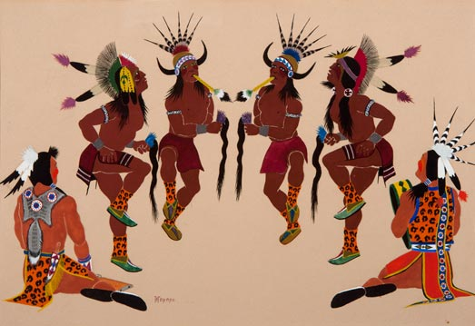

Stephen Mopope

Kiowa Scalp Dance, c. 1930

Watercolour on paper, 22.5 × 37 cm.

The Philbrook Museum of Art, Tulsa, Oklahoma